J/ Vembadi Girls’ High School
1St Term Examination -2017
English Language
Grade :9 Time :2.00 hrs

- Match the instructions with the suitable places and put the correct number in the boxes.[ one is done for you] ( 5 marks)
Instructions places
- Do not feed the animals in a library
3

- Fasten your seat belts in a shop
- Do not tear the books in a park
- Do not pluck flowers in a railway station
- Do not cross the line in an Aeroplane
- Check your balance in a zoo
- Choose and write the suitable preposition in the spaces from the list given below.
[on from in of into] ( 5 marks)
- It is the national flower ………………….Sri Lanka.
- People love to grow flower plants ………………………. their home garden.
- Oil is extracted………………………..the seeds.
- The leaves give out a big amount of oxygen……………….the air.
- Eagles built their nest……………………..the top of age old trees.

- Fill in the blanks using do not/does not/did not/will not . (5 marks)
- They ………………….know anything about camping earlier.
- Ramiya …………………… eat meat.
- Kala and her mother………………………. go to church every day.
- My father …………………………………buy vegetables yesterday.
- I …………………….. miss the chance in acting a drama next year.

- Read the paragraph given below about Raja and write a similar paragraph about Ramani. ( 5 marks)
Name | Village/ Town | Live with | Work in | Favourite game | Leisure time activities
Raja | Kandy | Grandmother | A factory kandy | Cricket | Playing Piano gardening
Ramani | Jaffna | parents | Bank of Ceylon | Basket ball | Watching TV
Raja’s birthplace is Kandy. He lives there with his grandmother. He works in a factory in Kandy. His favourite game is cricket. His leisure time activities are playing the piano and gardening.
Ramani’s birthplace is ……………………………………………………………………………………………………………………………………………………………………………………………………………………………………………………………………………………………………………………………………………………………………………………………………………………………………………………………………………………………………………
- Complete the dialogue using the right answers from the box.Write the letter of the correct response . (5 marks)
- How did you spend your holidays?
- Good morning!
- I had quite a jolly time
- Please do tell me something about the places you visited.
- Botanical gardens in Sri Lanka.

Anusha :- Good morning , Thivi, what an age since I saw you last!
Thivya :- (2)…………….! how happy to see you back in school again!
Anusha :- Well, (3)……………. . Did you go out of town any where?
Thivya :- No. Though I didn’t go out any where .(4)..................................
Anusha :- As for me, I went to Kandy and Nuwara -Eliya with my parents and visited (5)………………………And it was indeed an experience!
Thivya:- I am very glad to hear you went there. …………………………
Anusha:- I am sure . it’s my pleasure.
- Design a poster for “Dengue awareness” at your school.
Include the following.
Date, time, venue, organizer, chief guest

( 10 marks)
- Study the following picture and write 5 sentences.
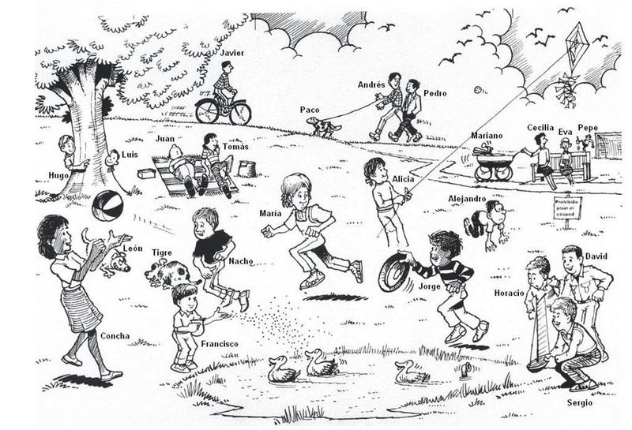
…………………………………………………………………………………………………………………………………………………………………………………………………………………………………………………………………………………………………………………………………………………………………………………………………………………………………………………………………………………………………………………………………………………………………………………………………………………………………………………………………………………………………………………………………………………… (5 marks)

- Underline the correct conjunction to link the clauses. ( one is done for you)
1 .Our school cricket team played well [and, but, or]lost by 6 runs.
2. The police arrived [and, but, or] the thieves were arrested.
3. I like you [and, but, or] I hate your gossip.
4. we can travel by bus [ and, but, or] catch the evening train.
5. Ravi fell off his bicycle [ and ,but ,or]broke his leg.
6. Raji went to the shop [and ,but, or]it was closed. (10 marks)

- Read the following information about Harish and complete his bio-data given below. One is done for you. ( 10marks)
d) 15,KKS Road, Jaffna
c)02 Dec 1981
b)Sri Lankan
a)Management Assistant
h)S. Harish
g)0777437926
k)single
j)5 years as an Audit Clerk at Raj company pvt Ltd
I )3 passes at G.C.E A/L
f)Sathiyaruben Harish
e) Jaffna Central college

- Name with initials :…………h……
- Name in full :-………………………
- Date of birth :-………………………
- Civil status : ………………………
- Nationality :…………………
- Private address:-…………………
- School attended:- ……………….
- Qualifications:- ……………….
- Occupation :- ……………….
- Work experience :-………………..
- Contact no :-………………… : :
:-
- Match the questions in A with the answers in B. write the letter of the question in the correct box. One is done for you. (1X5= 5 Marks )
 | A |  | B
1 | ) Hello, may I speak to Anu please? | F | Certainly here you are | A
2 | Are you feeling better? |  | Yes go straight ahead then turn right. | B
3 | would you mind showing me your passport |  | No , thank you. | C
4 | Excuse me could you tell me the way to the post office please ? |  | No, I didn’t. It was too long. | D
5 | Would you like a cup of tea? |  | Yes, I’m much better, thanks. | E
6 | Did you like the film? |  | Sorry, she’s out. Can I take a message? | F

- Fill in the blanks with most suitable words given below.
[Was, happened, with, her, worried, were, us, found, bundle, opened, in ]
When I 1)………was………………. a small boy of about seven or eight years, I used to play 2)……………………………… my little sister Ashani. One day when we 3) ………………………………… playing hide- and- seek a strange thing 4)…………………………………….. . I searched for my sister everywhere but could not find 5)………………………… and I became 6)……………………………………..and told my mother. Both of 7)……………….......... looked for her and at last 8)……………………………. her hidden among the hey 9)…………………….. the cattle-shed. She lay here fast asleep on a 10)……………………… of hay. She 11)……………………………. her eyes sleepily when I shook by the shoulder.
( 10x1=10 marks)

12.Read the paragraph and answer the following questions.
Three wicked men went in search of jobs. They walked a long way in a forest and were tired. When they were resting under a shady tree, two of them fell asleep. The other sat on the big stone found under the tree and kept on watching. Suddenly a coin from his pocket fell down and rolled under the stone. He removed the stone to find his coin and the sound made the others stir from their sleep. When the stone was removed, to their surprise, they saw an iron safe full of gold and silver coins, in the pit below. They were very happy about their new found treasure and sent one of them to buy sweets and drinks to celebrate the occasion.

Meantime the other two planned to kill him, and share the fortune equally. The third, who went to buy sweets and drinks was equally greedy, thought of owning the treasure all to himself. He bought some sweets and wine and mixed some poison into the wine. When he came back, the other two unexpectedly attacked him and killed him at the very spot. They were greatly pleased, and ate the sweets and drank wine with much merry-making. Their pleasure no longer lasted and they fell dead embracing the iron-safe.

- Why did the three men set out on their journey? ................................................................................................................................
- Why did he lift the stone? ……………………………………………………………………………………………………………………………..
- What did the other two do during the absence of the third? ………………………………………………………………………………………………………………………………
- Why did the third poison the wine? ………………………………………………………………………………………………………………………………
- At the end who owned the treasure? ……………………………………………………………………………………………………………………………….
( 1x 5 =5marks)
- What do the underlined words refer to
- They : ……………….
- He: …………………… (1x2 =2marks)
- Find the similar words for the following from the text
1.Having too much of desire : ……………………………….
2. Valuable object : …………………………………... (1x3 =3marks)
3.Unexpected : ……………………………………
13.Write on one of the following. Use about 150 words.
- Let’s protect our environment.
- How do you spend your spare time in useful ways?
- Significance of flowers.
(10 marks)

